Done by: Aashish Chaudhary
Mount the Cifs/Smb share with credentials file.
Tools used: samba, cifs-utils

Overview:
In this project, I will mount the CIFS/SMB share from Server to Client using Server Message Block (smb) protocol. Unlike NFS, CIFS is compatible across the multiple environments and are mostly used in Windows setup. This project will be similar to NFS project, I am trying to achieve the same goal. The only difference here is the approach, how we carryout the project.
The common mental model of how to mount any share is, first we decide what to share. Is it file or directory ? Which device will serve as the fileserver? Let’s walk through our project.


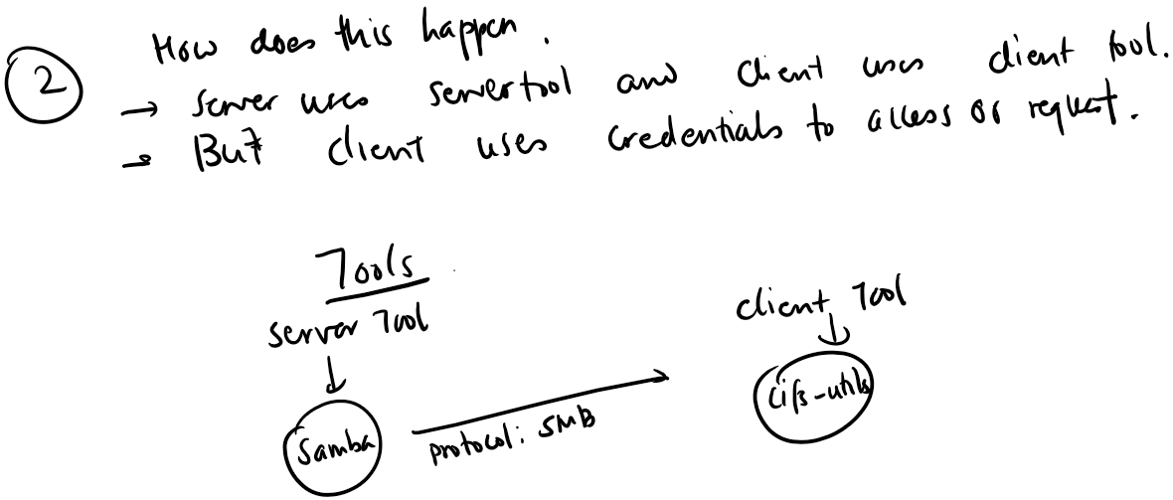
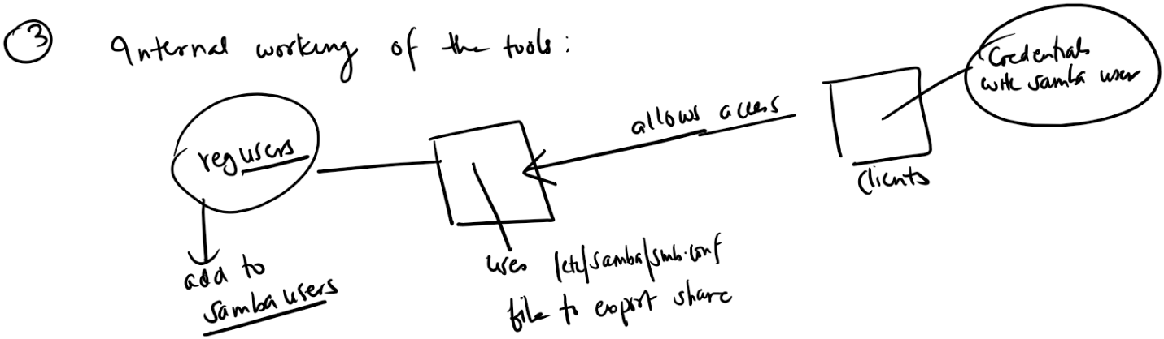
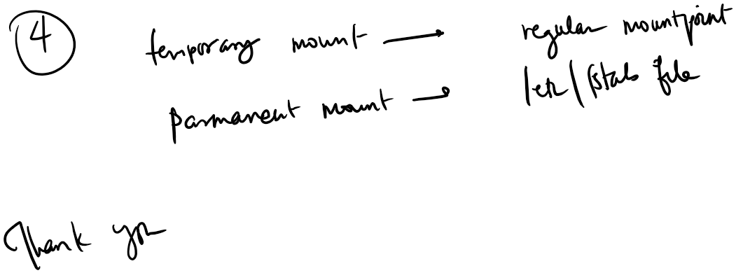

The above hand-note clearly shows the entire project visually. Let me tell you couple of things that might create confusion for anyone reading this especially about the internal working of the tools.
The whole file share uses the SMB protocol and samba is the program that uses this protocol. Once the samba is installed, we need to decide which regular users are going to have samba privilege (lets say samba access). We add user or group in the samba user group’s list. Once /sharefolder and samba user is ready. We configure the /etc/samba/smb.conf file and we apply changes through daemon reload .
Similarly, in the client machine, after we install cifs-utils package, we create the credential file that holds samba user’s username and password. And mount the filesystem to the mountpoint (both temporary and permanent).
Probable Issues:
- We might use the /absolute/path/to/sambashare. It doesn’t work. Why? /etc/samba/smb.conf file defines the path/of/sharefolder and name. We use name for this mount
- We might encounter the permission issue to read and write of the /sharefolder from the client machine. Don’t forget, any changes to the share folder will happen as the user defined in credentialfile.
- Credentialfile might have permission issue of being less secure. So, appropriate permissions should be set.

In this small project, I have setup sambashare and mounted to the client machine. Both read and write functions happen successfully. At the same time, the mount can be mounted permanently from /etc/fstab file. I have included all the steps and commands in the CLI documentation.

